MVP Artegee User Stories

Many of the original features to be stripped away

* No profit share scheme
* No collections
* No price ranges
* Will focus solely on paintings

Features to remain

* Art will not have a price
* Accounts for both artists and buyers will remain
* Buyers will chat directly to artists through a Facebook chat style feature
  + Within this chat they will have a make offer button where they can input an amount
  + Artist will then receive an accept button, if they click, launches stripe for payment

Front end

* The original UI/UX will be updated to be minimal and modern.
  + Will blend aspects of social media and e-commerce together
  + **All designs in this spec use the old designs, this is just to get a rough feel for how certain pages could look like**
* The below design theme will be used across the site. Below is an example of how an artists page would look

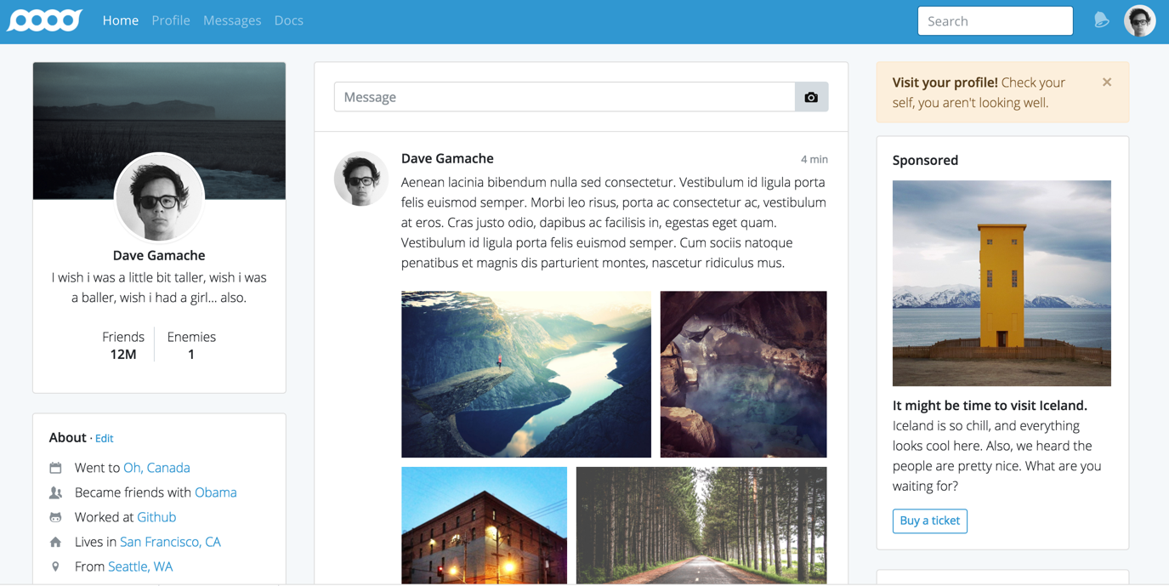

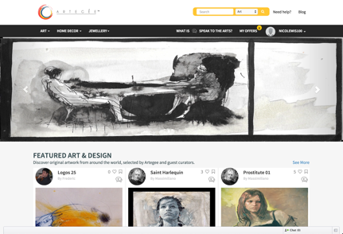

As a guest to the site

I visit the root path

I see details of what the application is about

I see featured artists of the day

I see navbar where I with a link to sign up

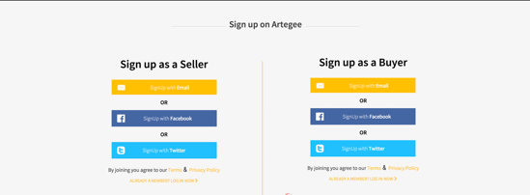As a guest to the site

I visit the signup path

I am able to sign up as either an artist or buyer [Oauth?]

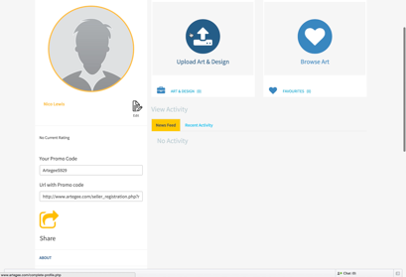

After clicking sign up as artist

I fill out my account information [Type form API]

first name, last name, username, email, password (mandatory)

photo, education, about, featured in (not mandatory)

I am then taken to my profile page

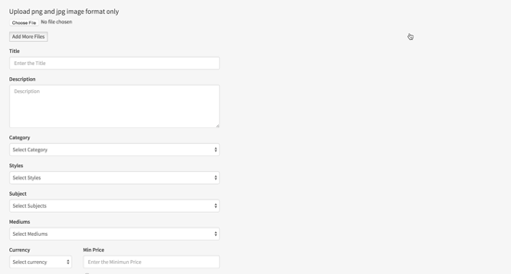

From artist profile path

I click add art

Taken to a form

Photo, title, description, dimensions_inches(mandatory)

I click submit

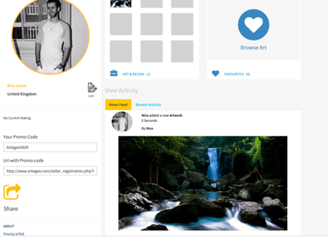I am taken back to my profile with the art piece showings

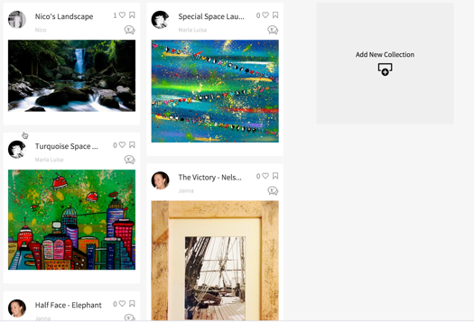As a guest to the site

I visit the sign up path

I click sign up as buyer

I fill in account information

first_name, last_name, username, email, password(mandatory)

I am taken to the art index page

Typeform Onboarding Questions

People like to see the face behind the art they are exploring. Can we have an image from you

(prompt them for image)

Hello Thank You for Joining Artegee

What is your first name ?

Hey [Name] nico to meet you. Whats your last name

Which email address should we use for you

(don’t worry, were not going to spam you)

What is your favorite genre of art

* Pop art
* Fauvism
* Modern

How many years have you been working on your craft?

Random Giff Break

Maybe take a break and drink a glass of water

You get to go to lunch with one of these artists who would it be

Michael Angelo

Pissaco